Language and software used: Spark,Scala,Idea, SQL

Step1: Import Dataset we want, here takes a example of Lost table and found table

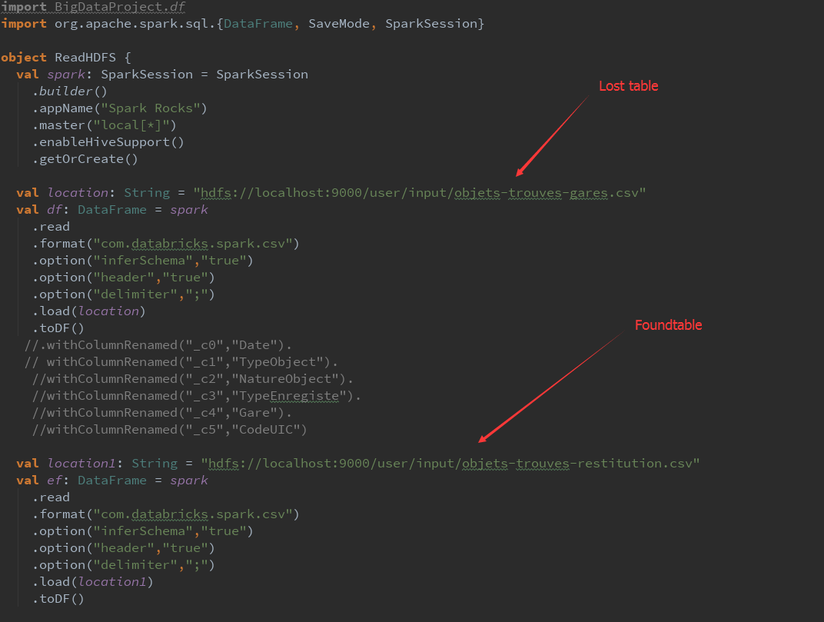

Step2 : Run queries and Create Tables we need:

Here are just some examples ,we can manipulate the tables accroding to our needs

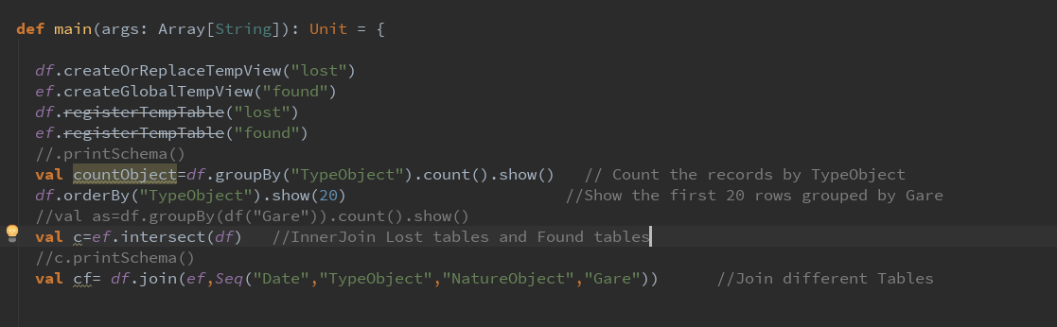

Step3 : Save results on hdfs



Step4 : Answer the questions requested for the project

For example, we know from the follwing graph that the passanger are most likely to lose the Sacs and Portable, we can remind them to be careful

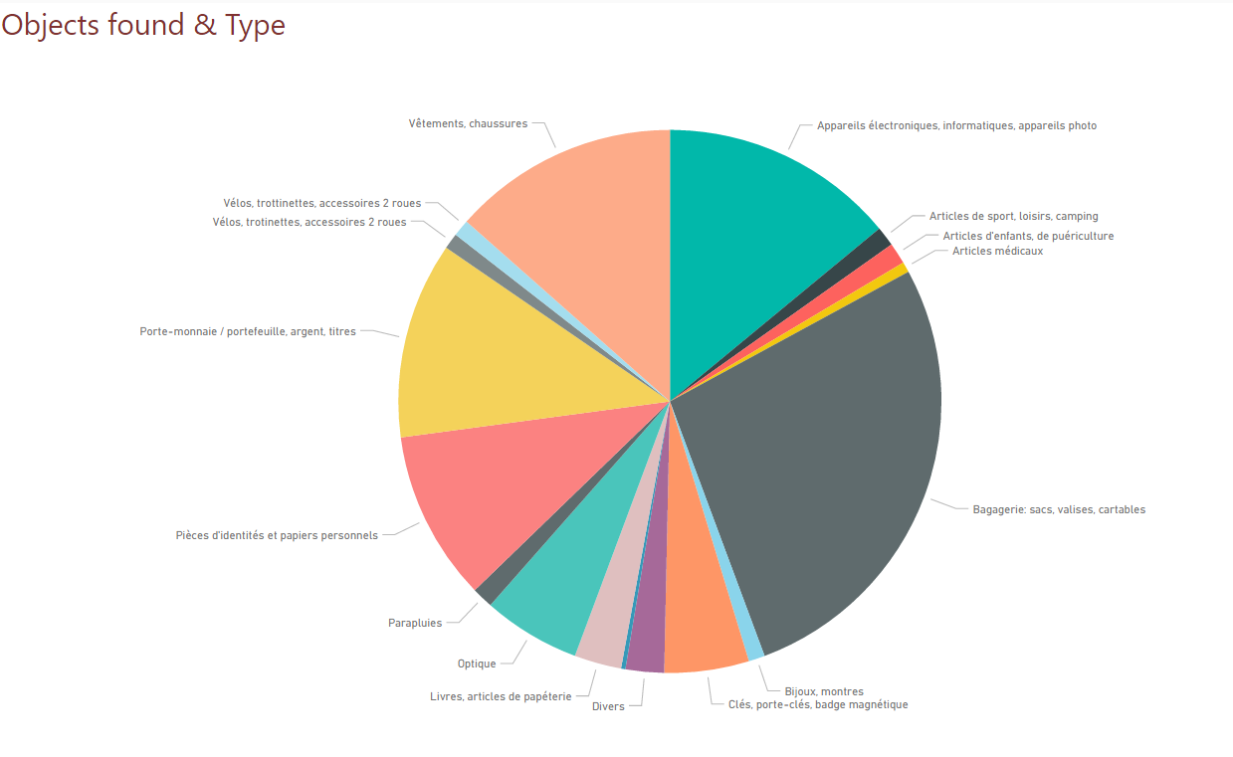

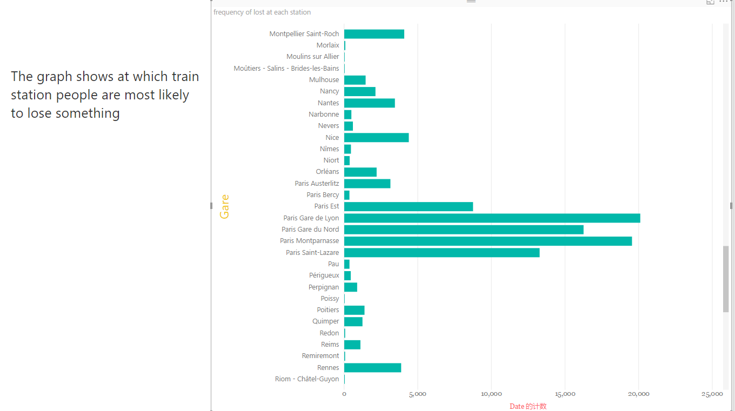

We can also find that the passangers should pay attention to the Railway stations

In Paris